Repo URL: https://github.com/Adriann-ai/Brain-Tasks-App.git

**Requirements:**

1. AWS Code Build # to build docker image
2. AWS Code pipeline # to helps to integrate code build and deploy in ECR
3. IAM role
4. Docker
5. AWS EKS
6. AWS ECR
7. GITHUB
8. ARGOCD as CD part
9. Prometheus and Grafana

GITHUB:

Push the source code to github repo from local repository

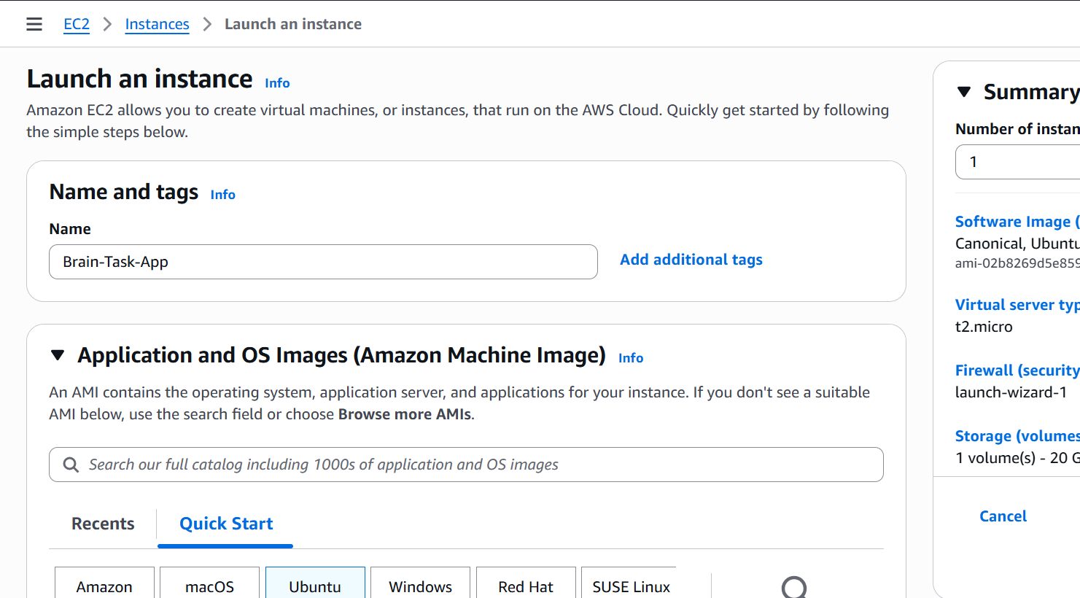

Just Pushing the file from local desktop to remote server using WinSCP, this is just for temporary docker container creation.

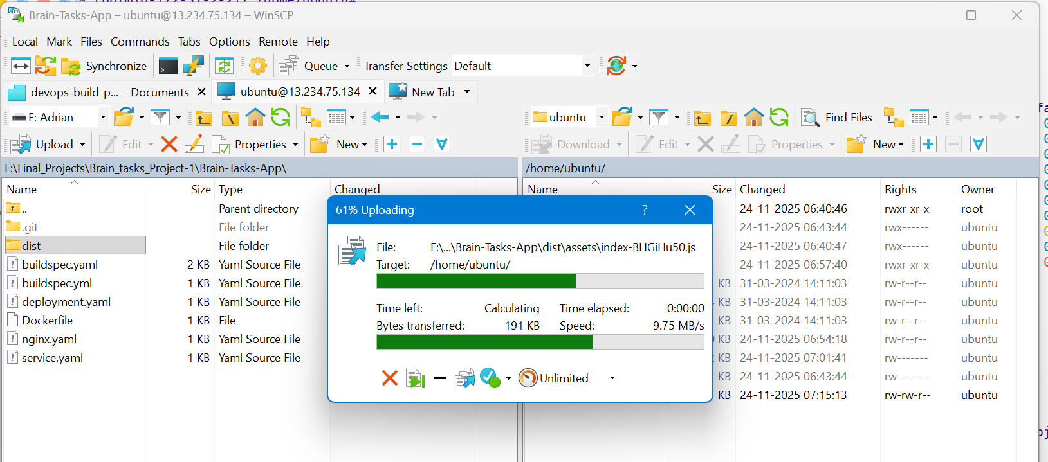

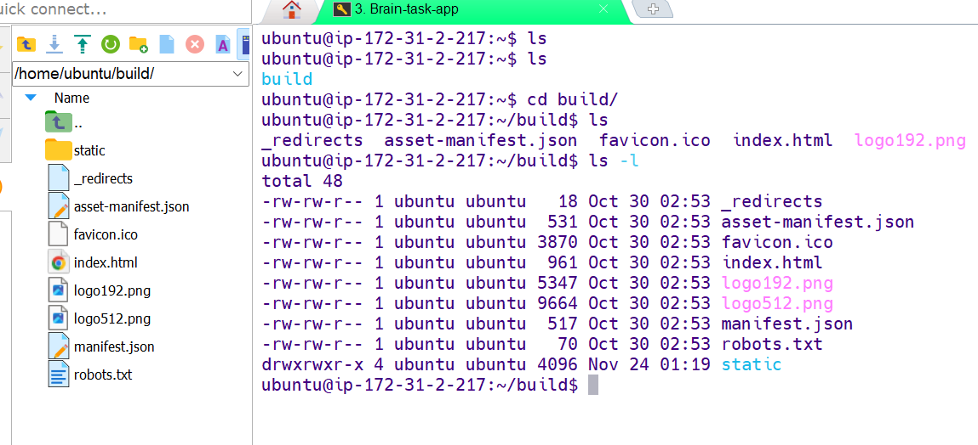

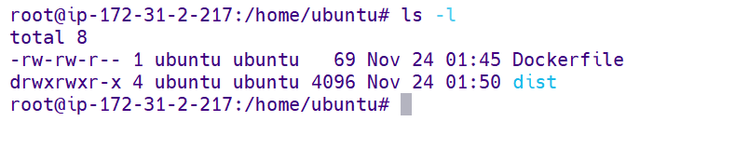

Installing Docker

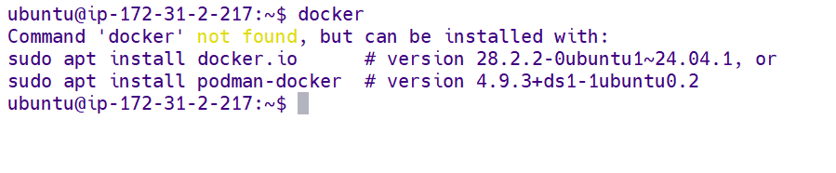

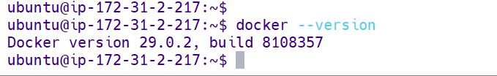

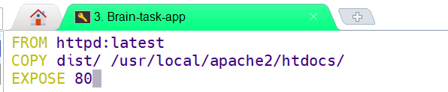

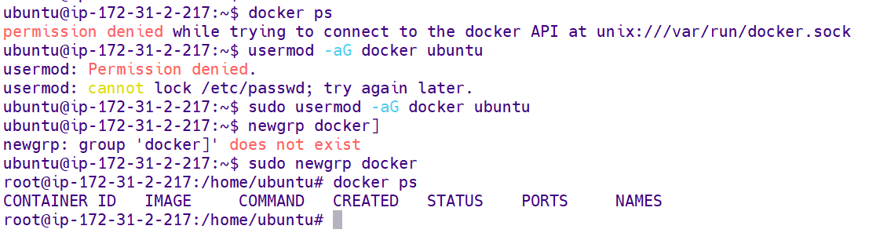

Snapshot of building docker image and creating container with port forwarding 3000

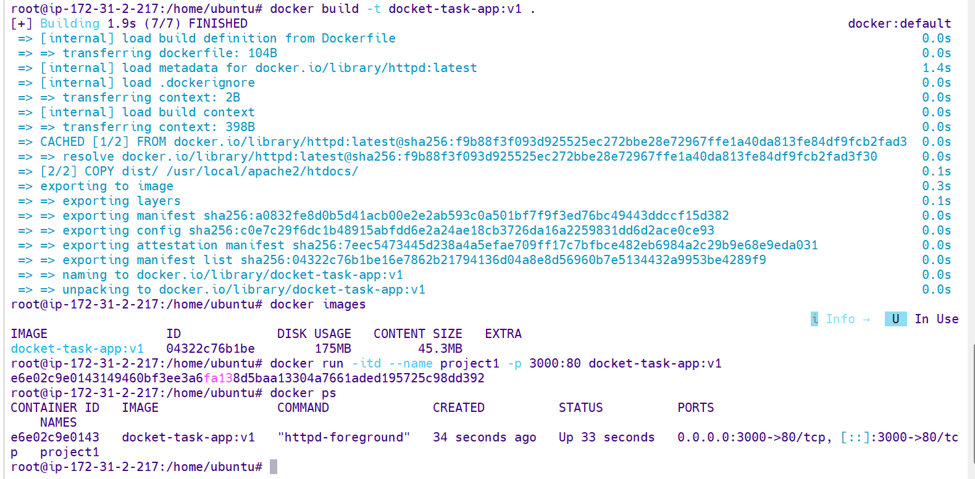

Can access the site with port 3000

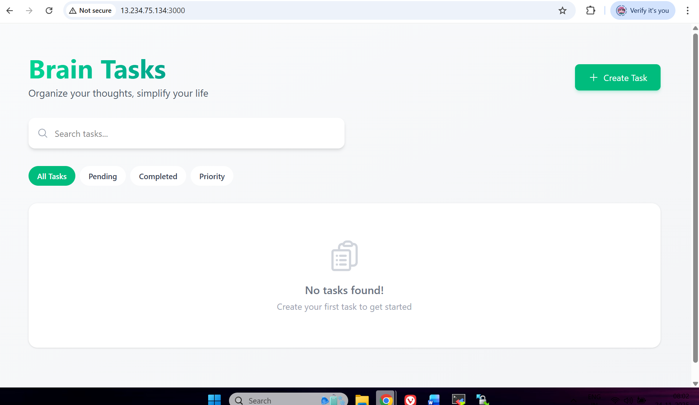

Creating ECR to push the docker images

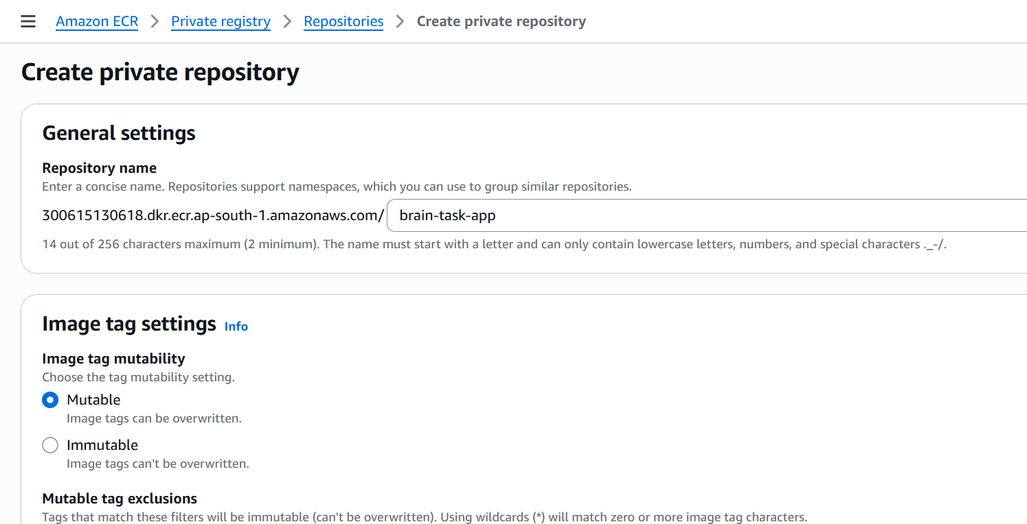

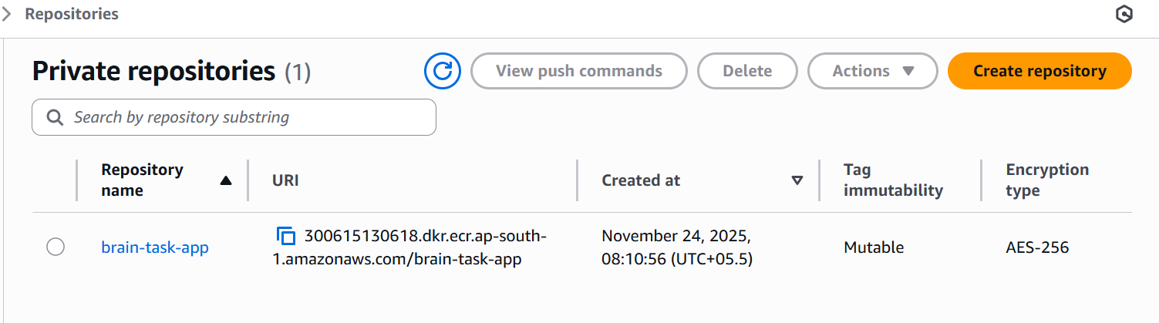

For CI part I’m using CodeBuild with “buildspec.yaml” file and for CD part using ArgoCD

Code Pipeline is used to automate from Github repo

Dockerfile

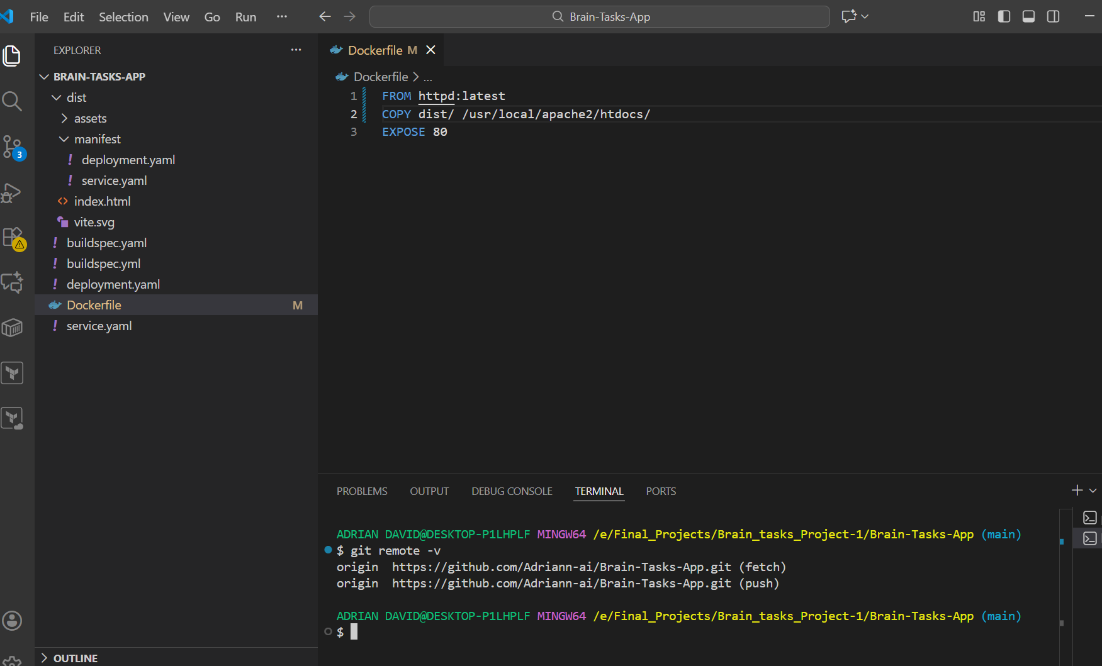

Buildspec.yaml file to build the image and push to ECR

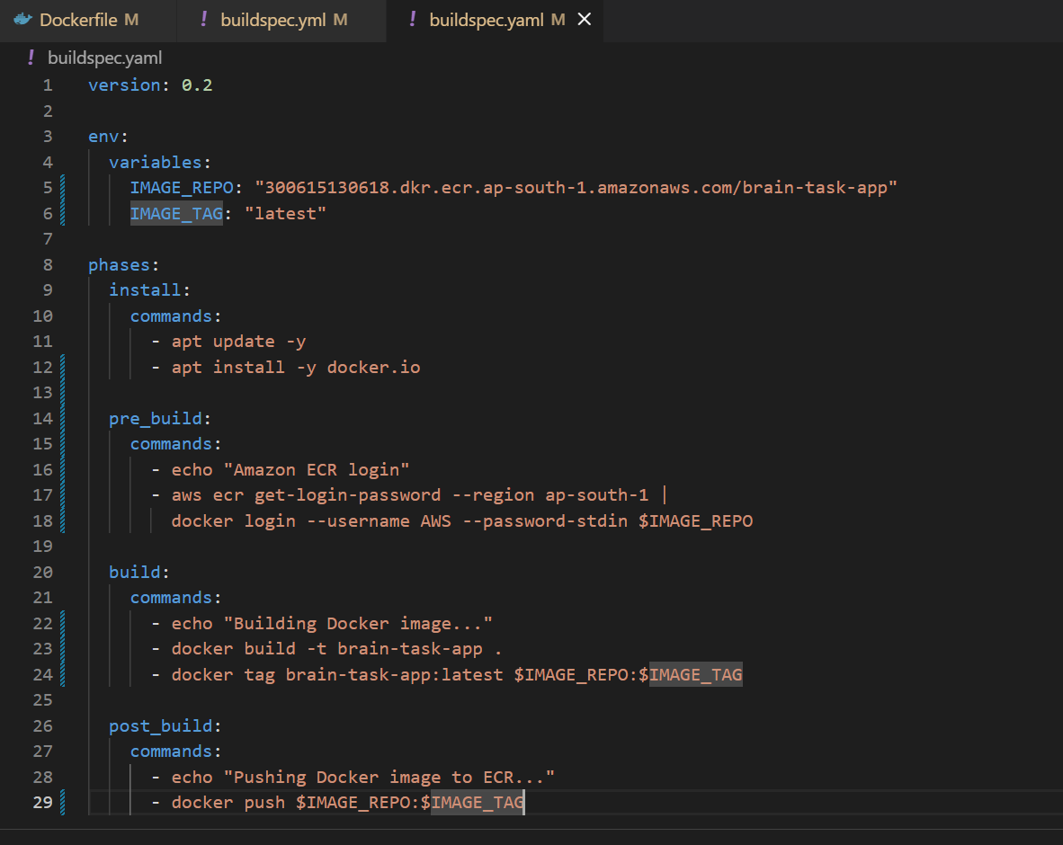

Source code made ready in local and pushing to github

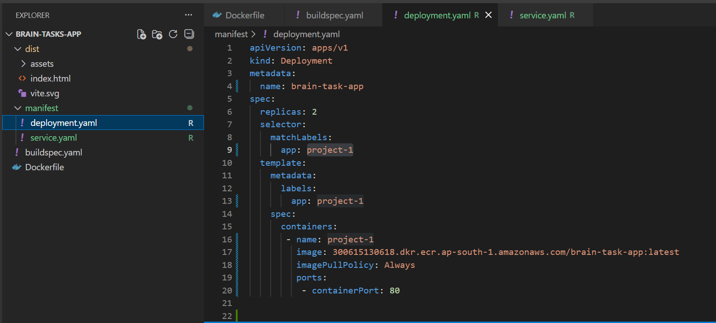

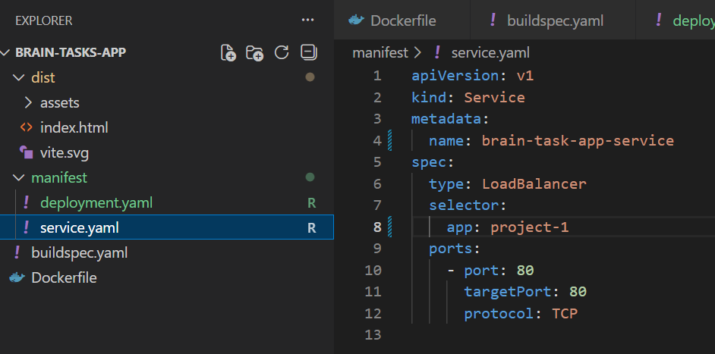

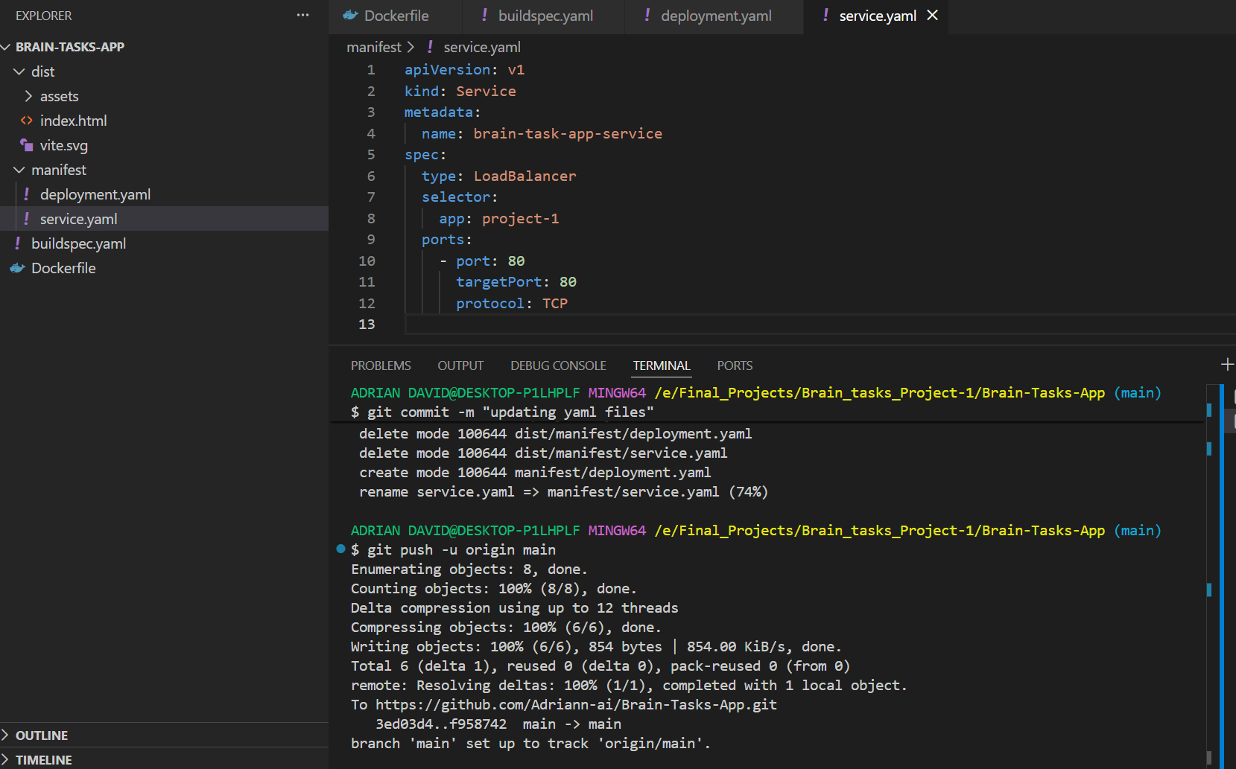

Configuring Codebuild

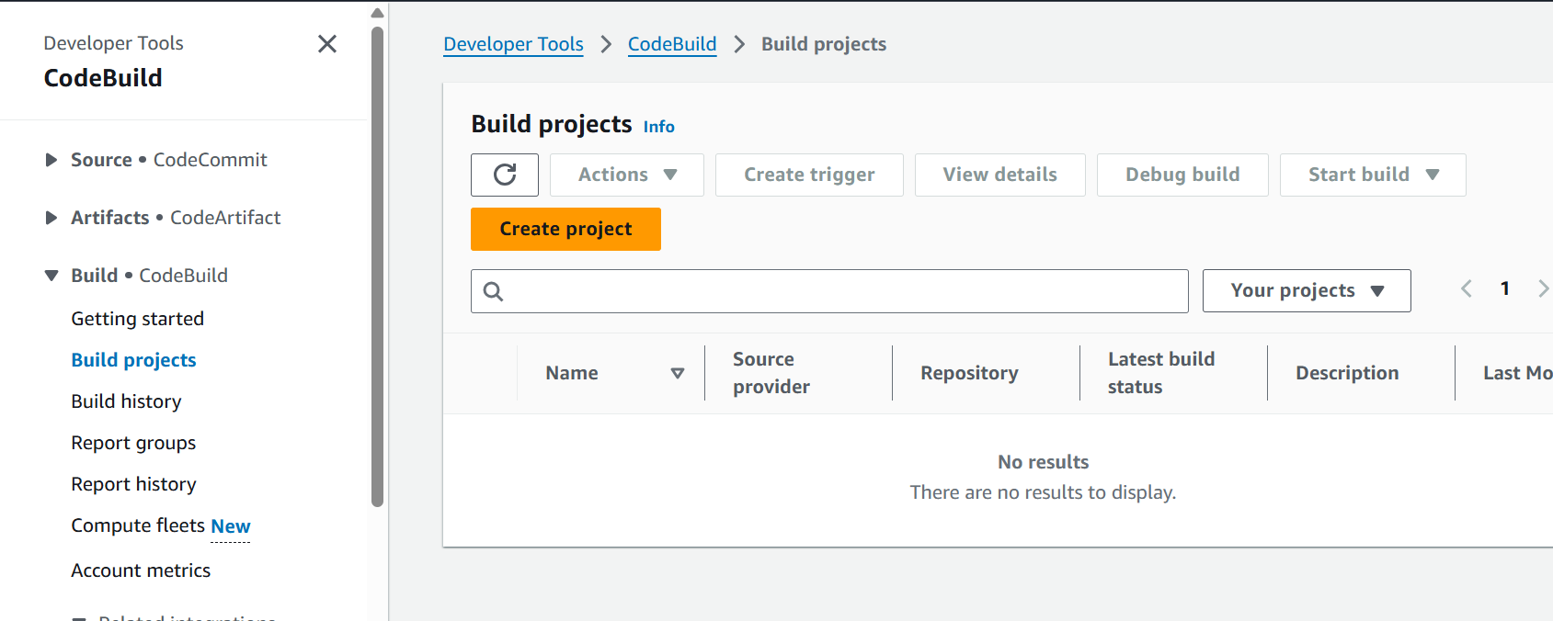

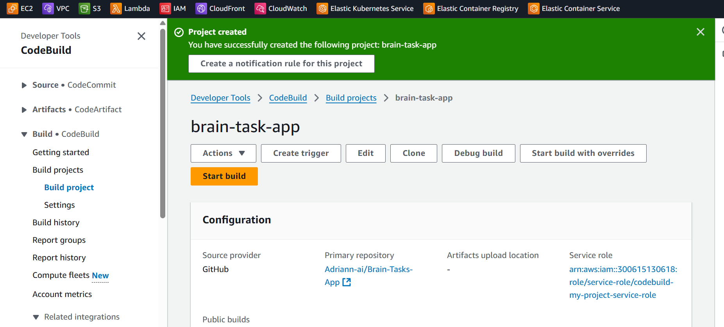

Setting up codepipeline

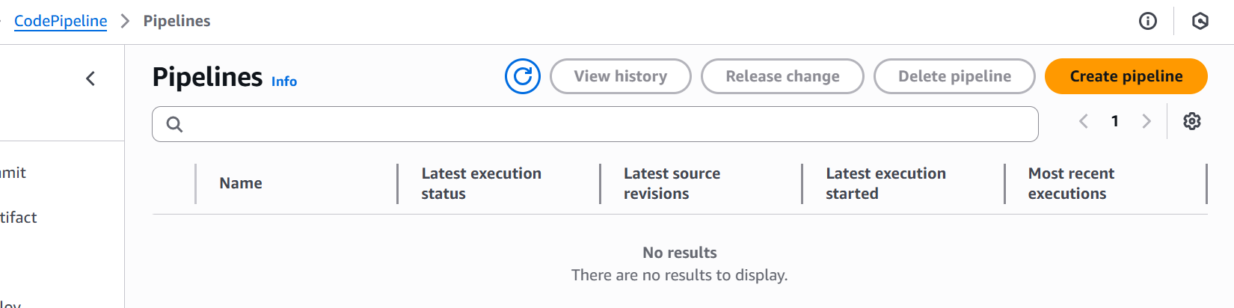

Pipeline setup done

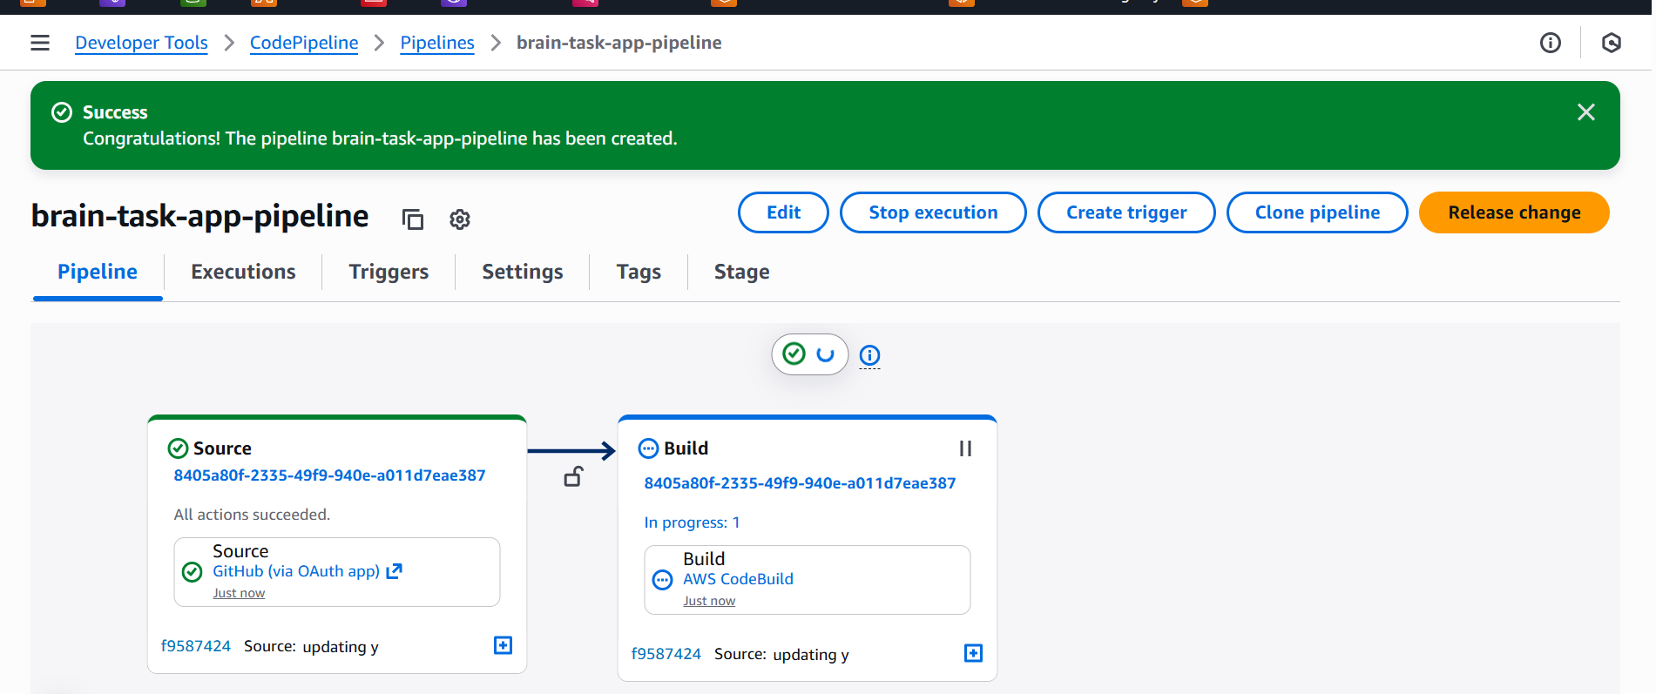

Build and push is succesfull

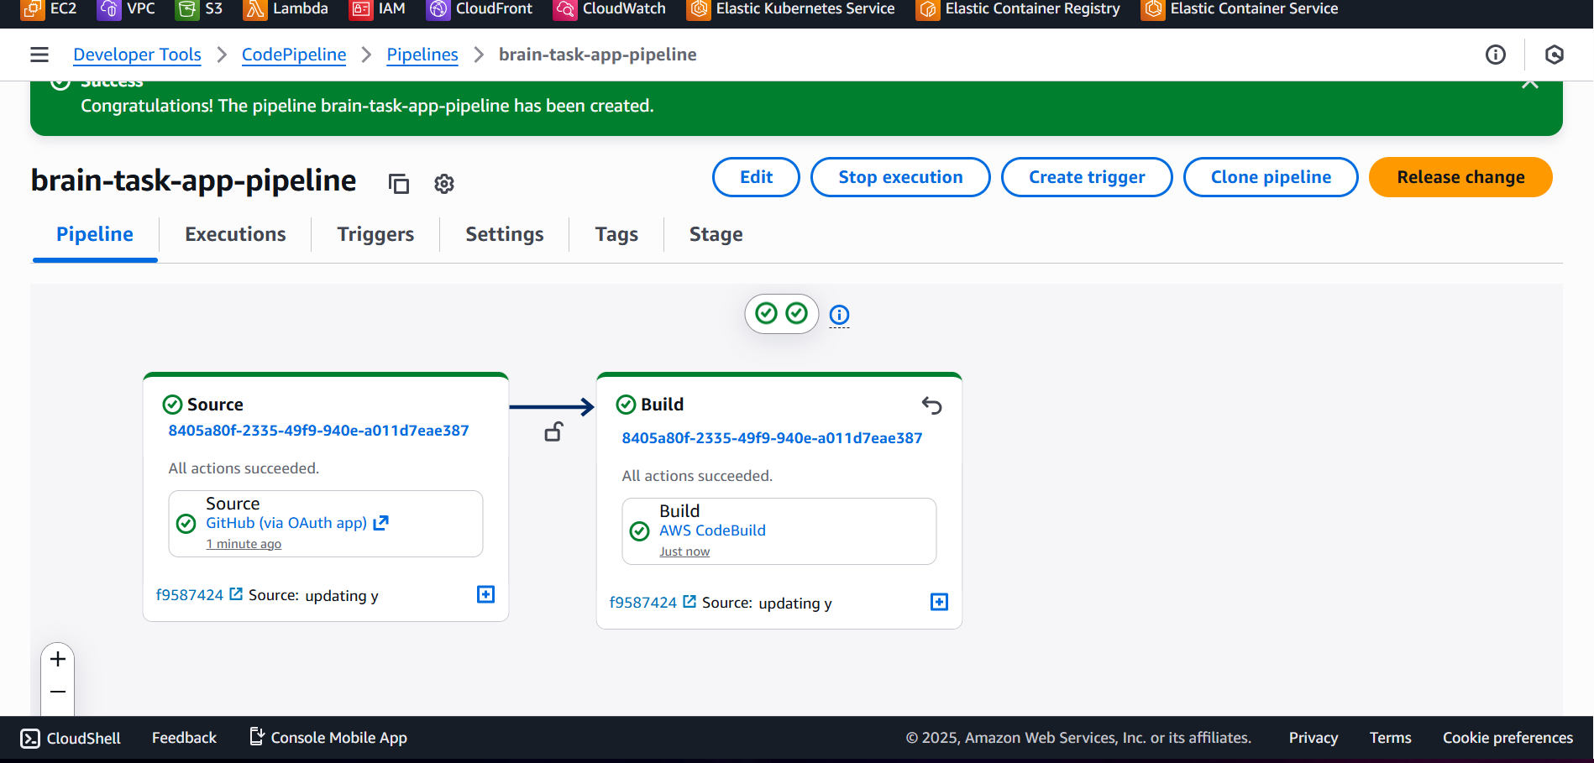

Latest image in ECR

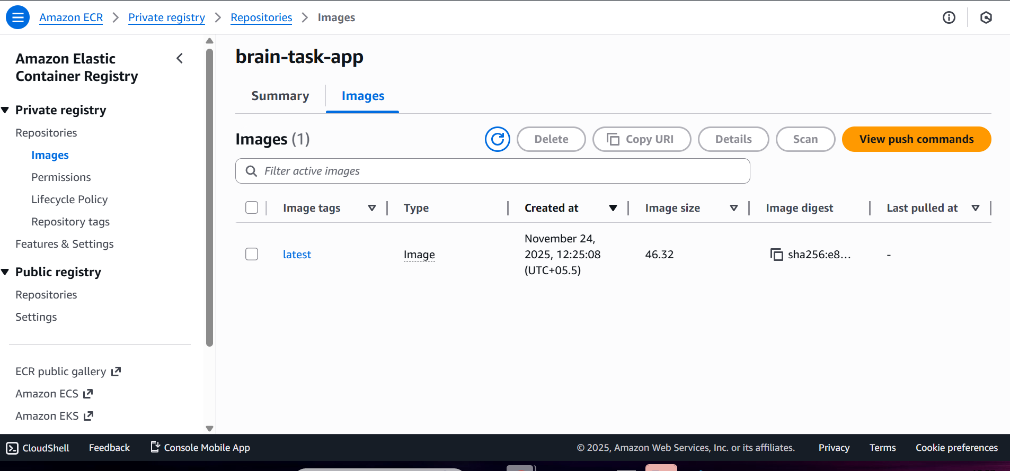

Creating EKS Cluster and Node group

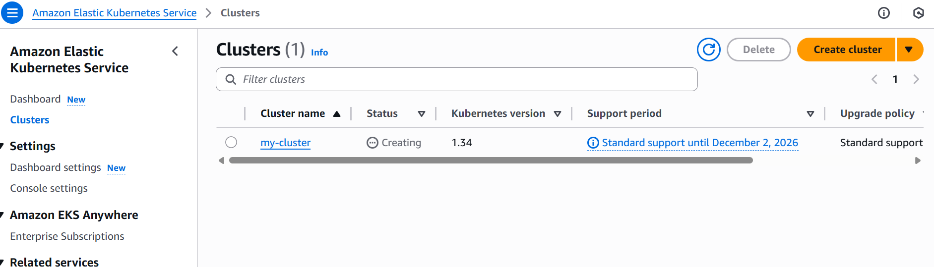

Creating ArgoCD

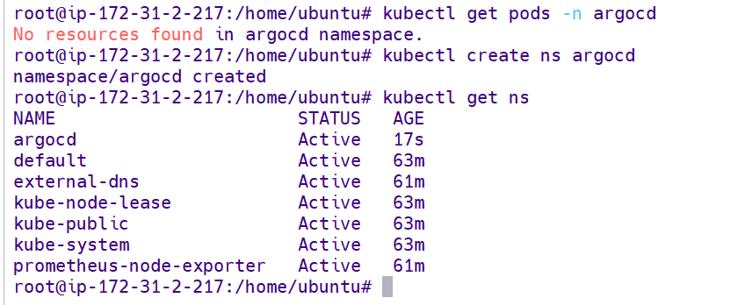

Installing Helm

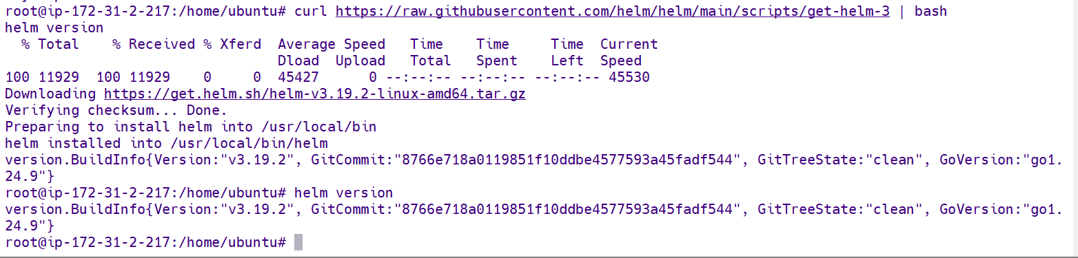

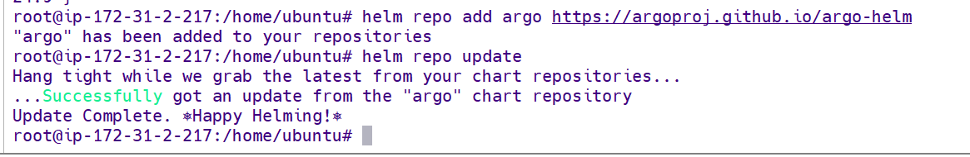

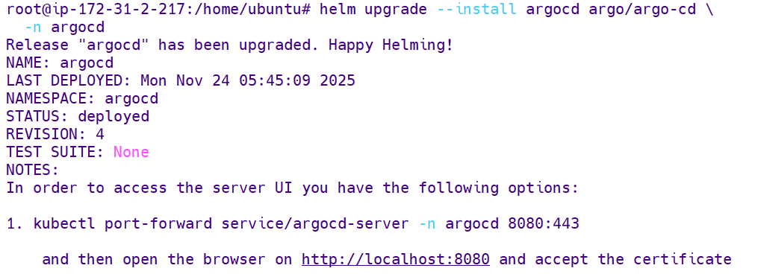

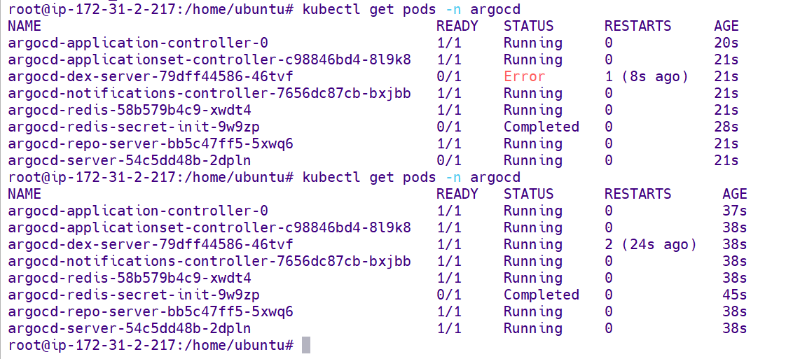

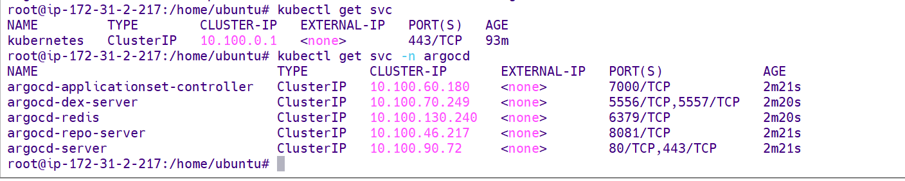

Created Nodeport service to access the UI

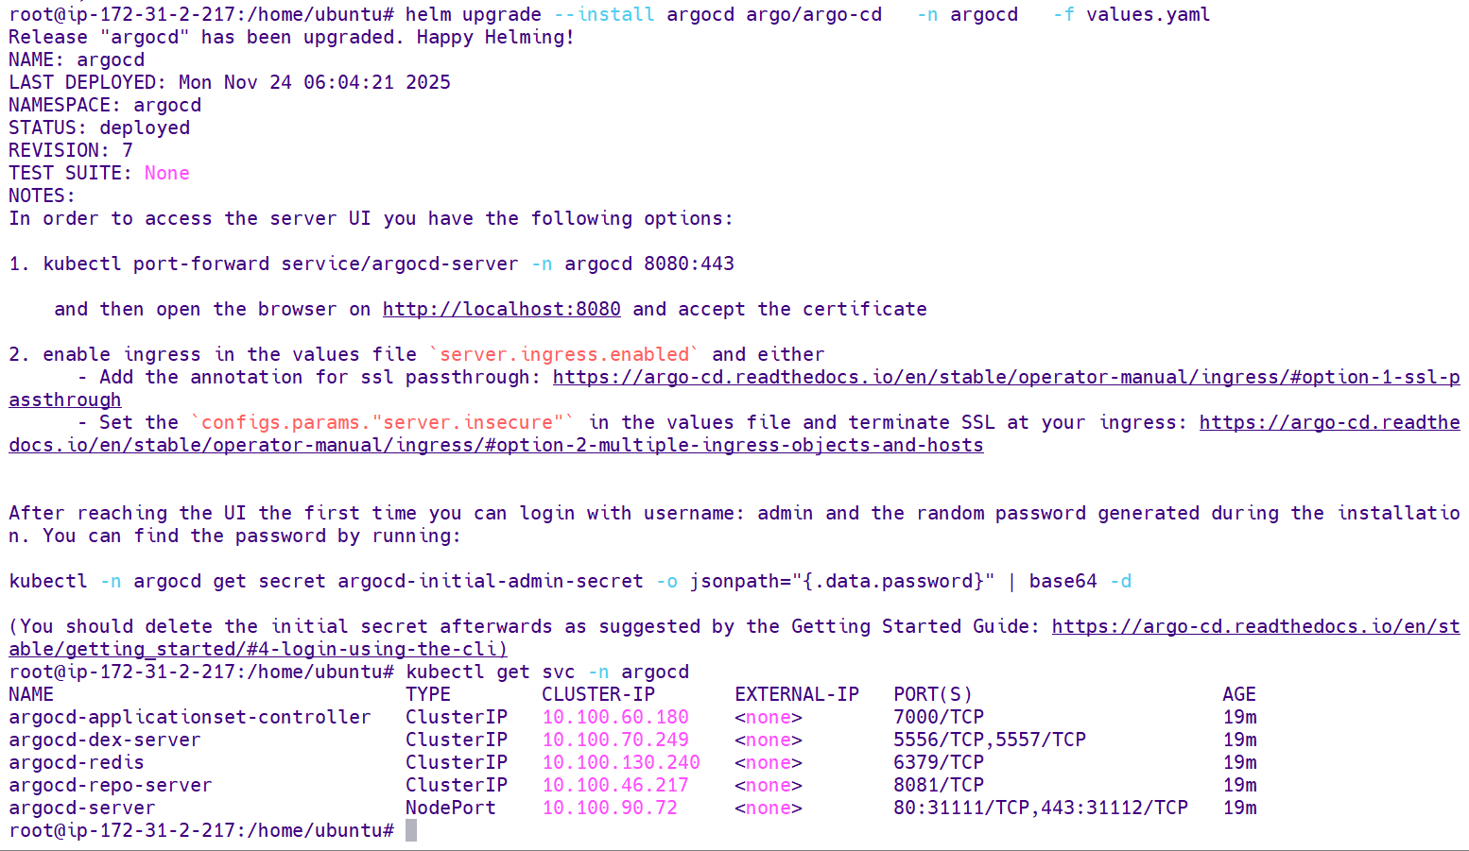

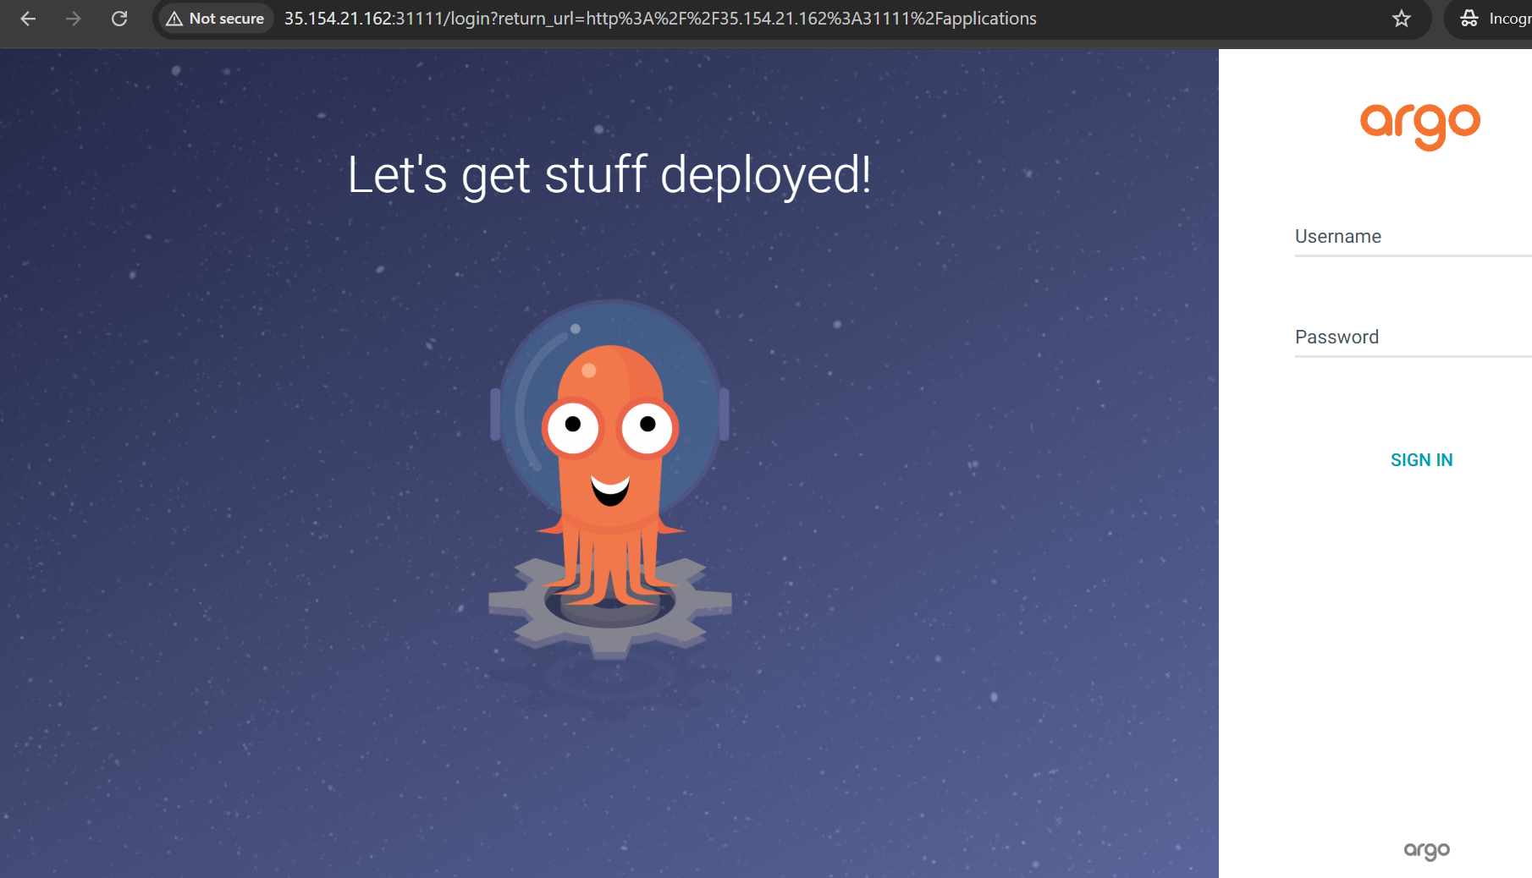

To get password to login UI



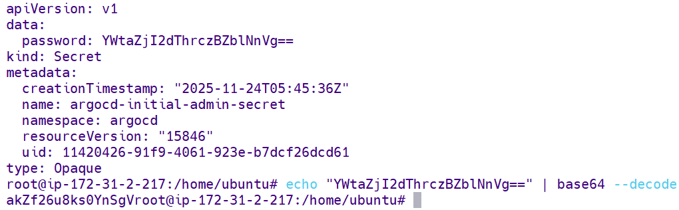

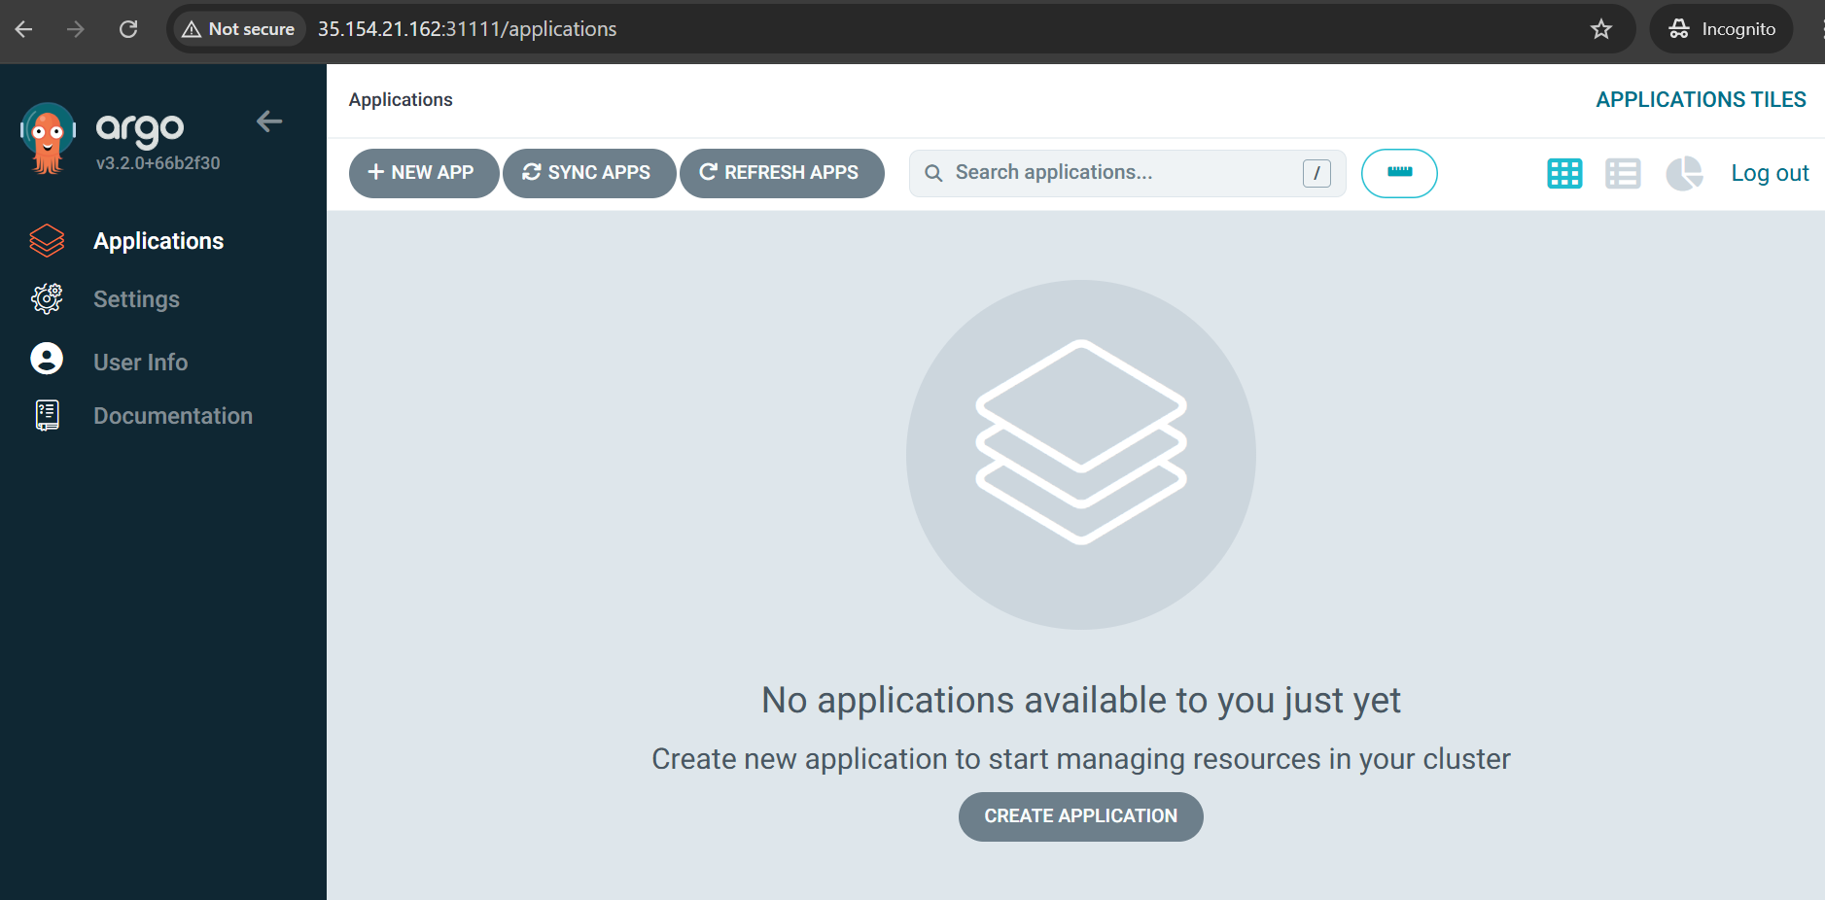

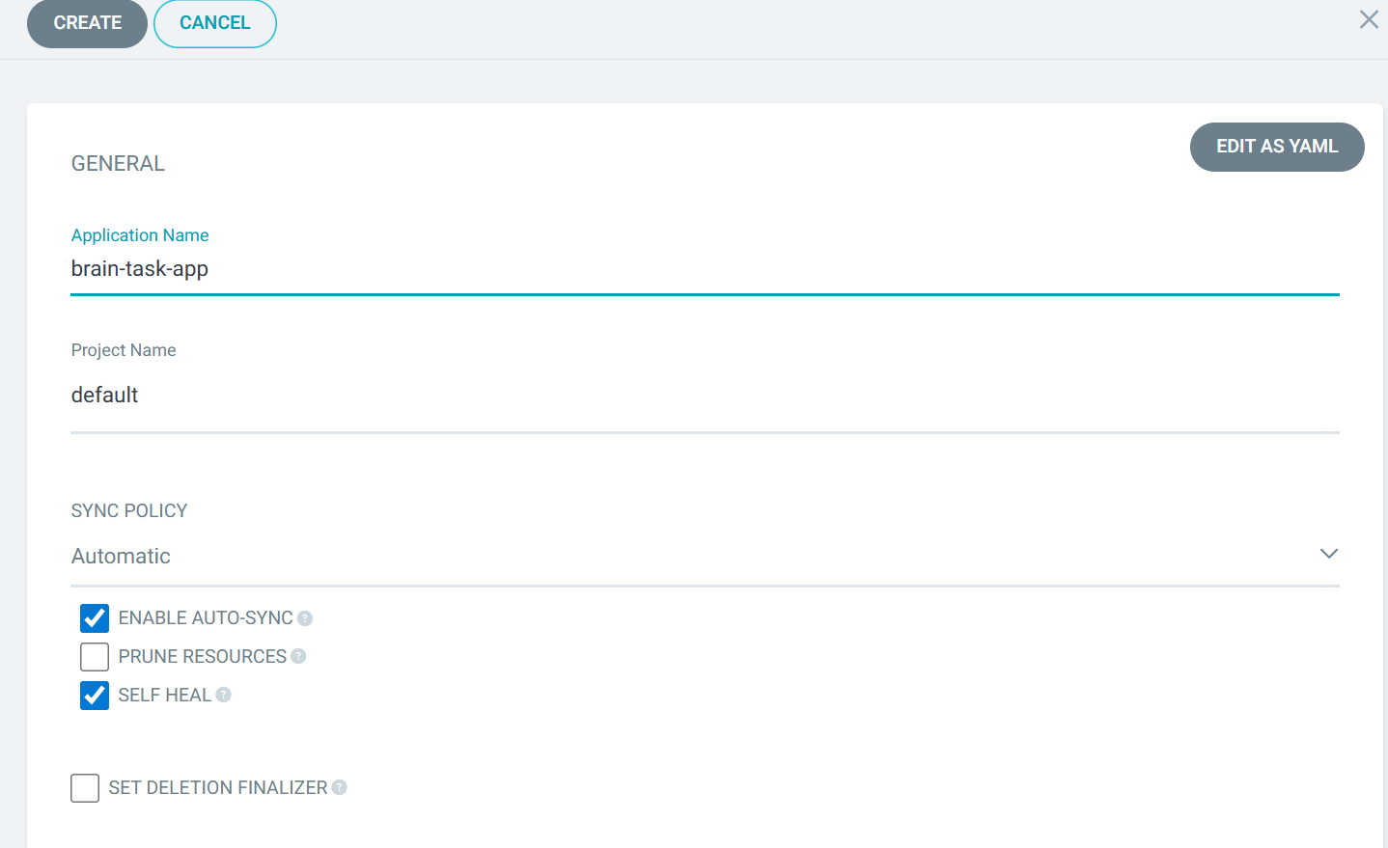

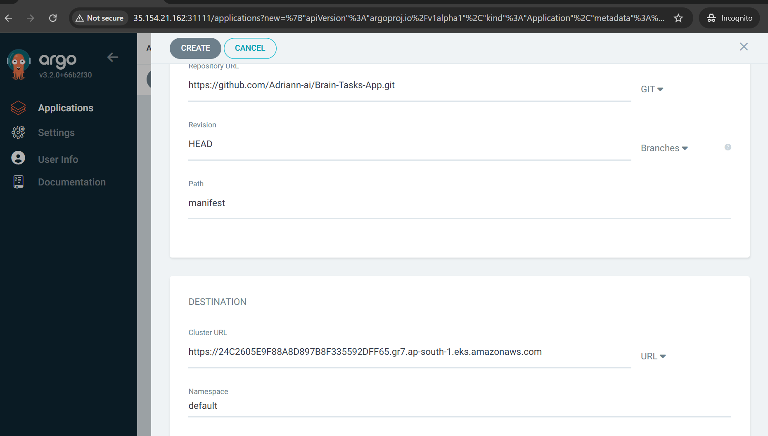

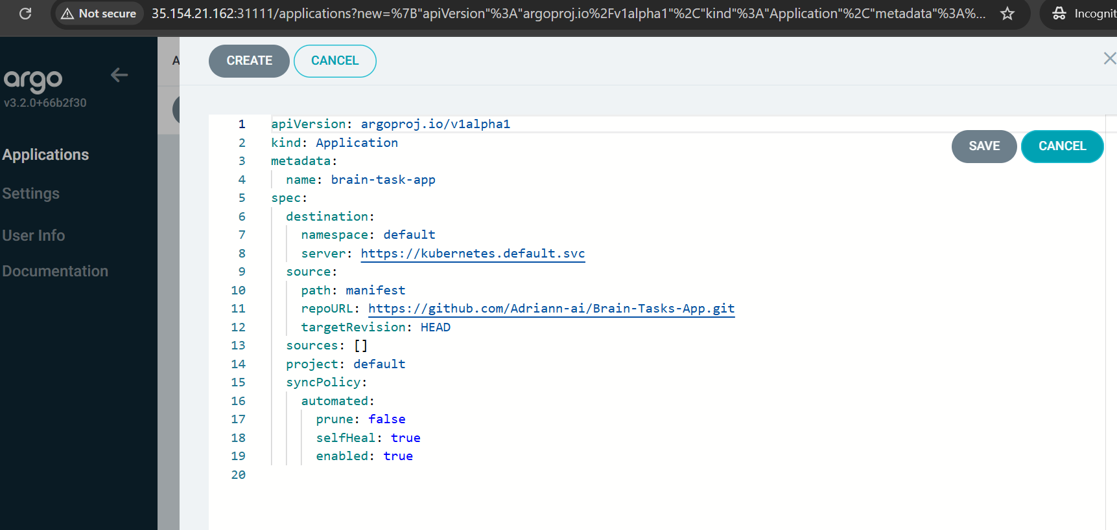

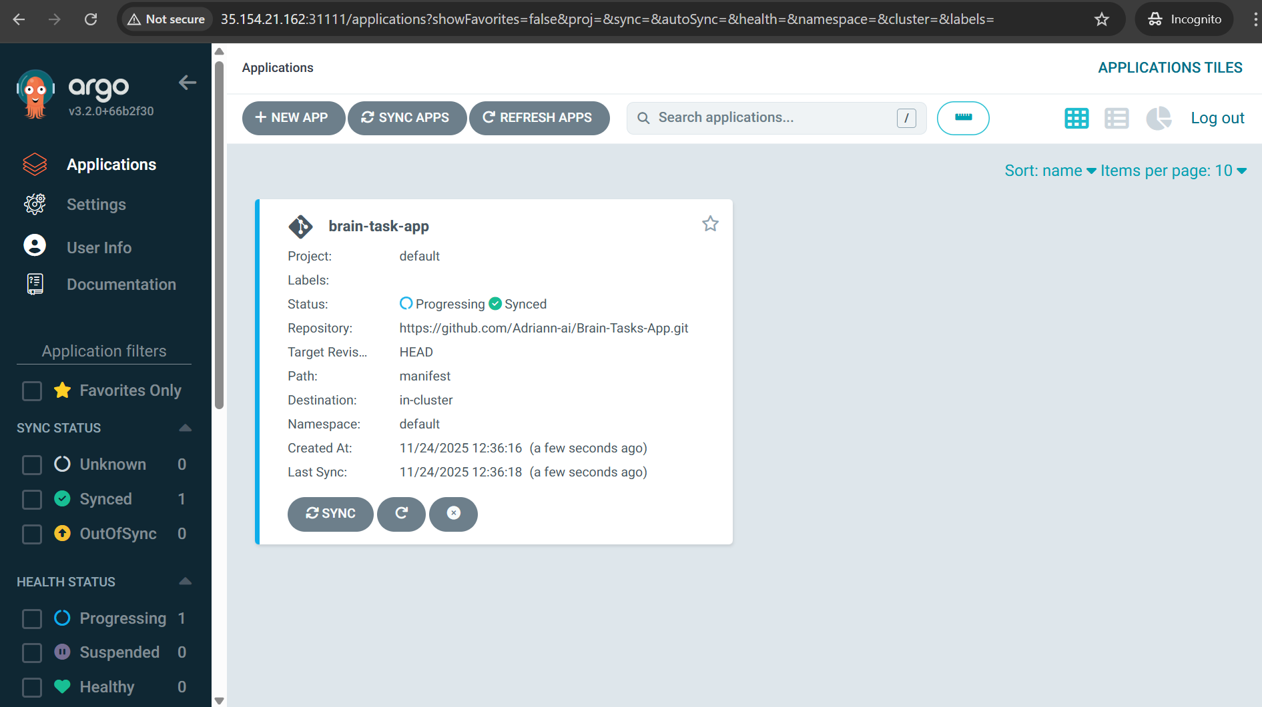

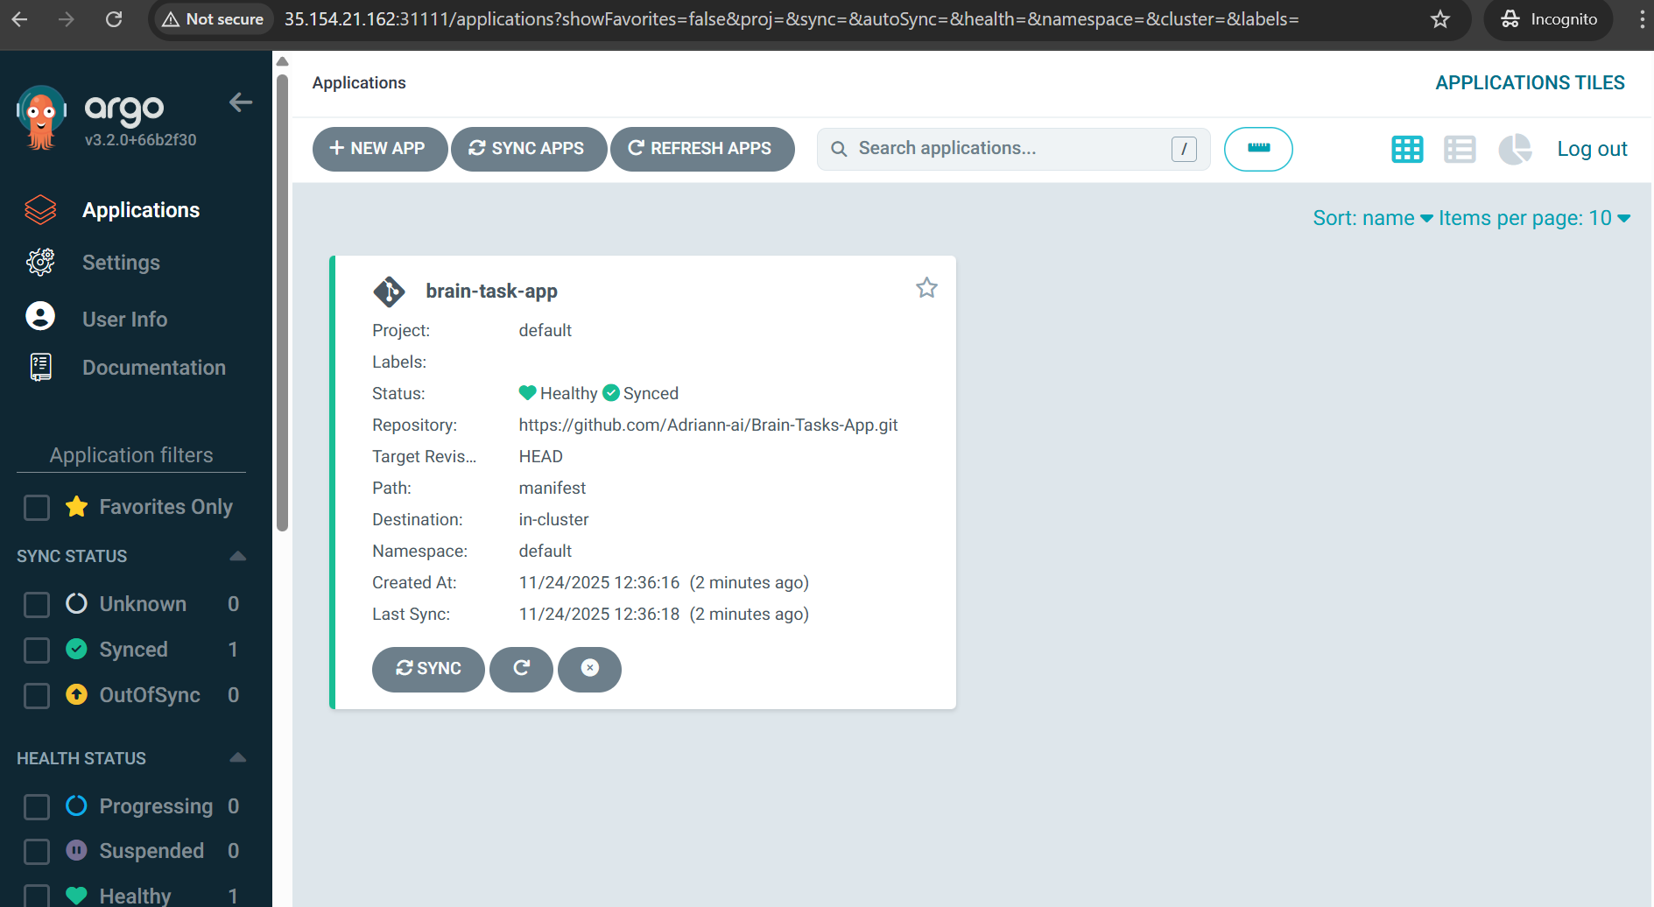

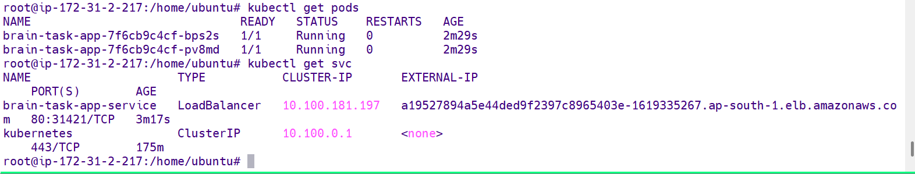

Loadbalancer service created through pipeline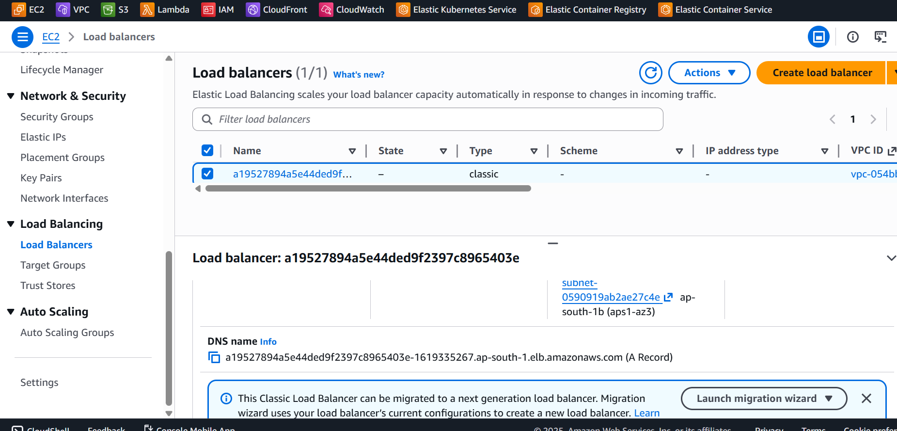

Able to access the site

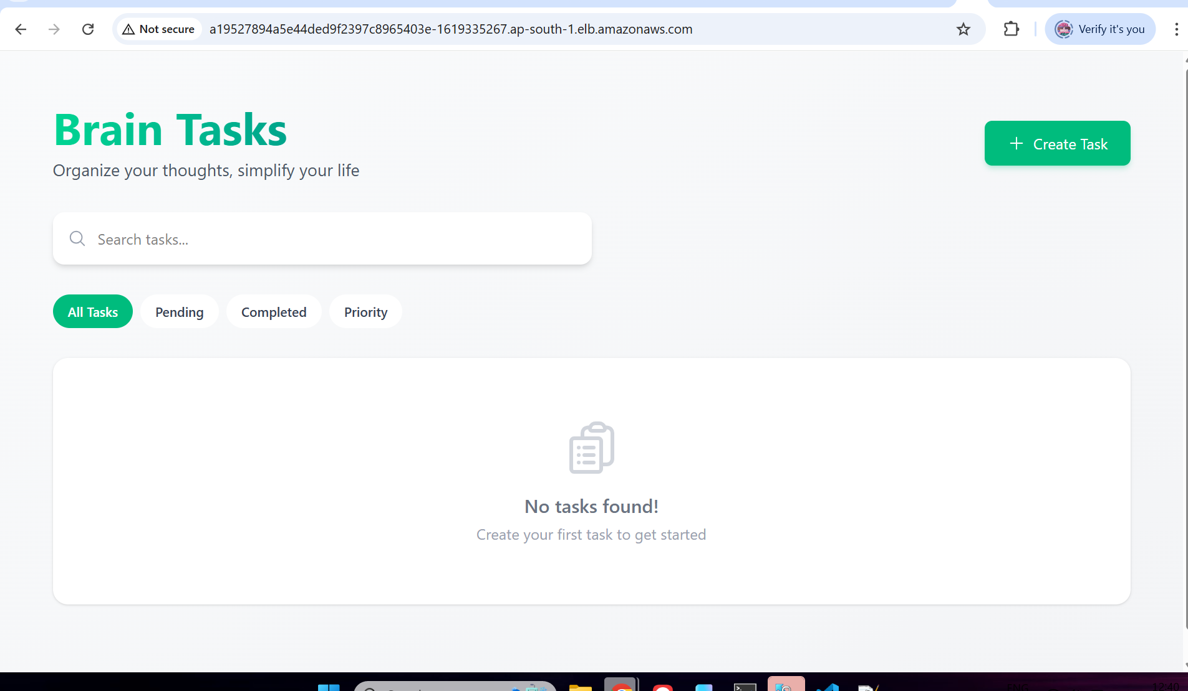

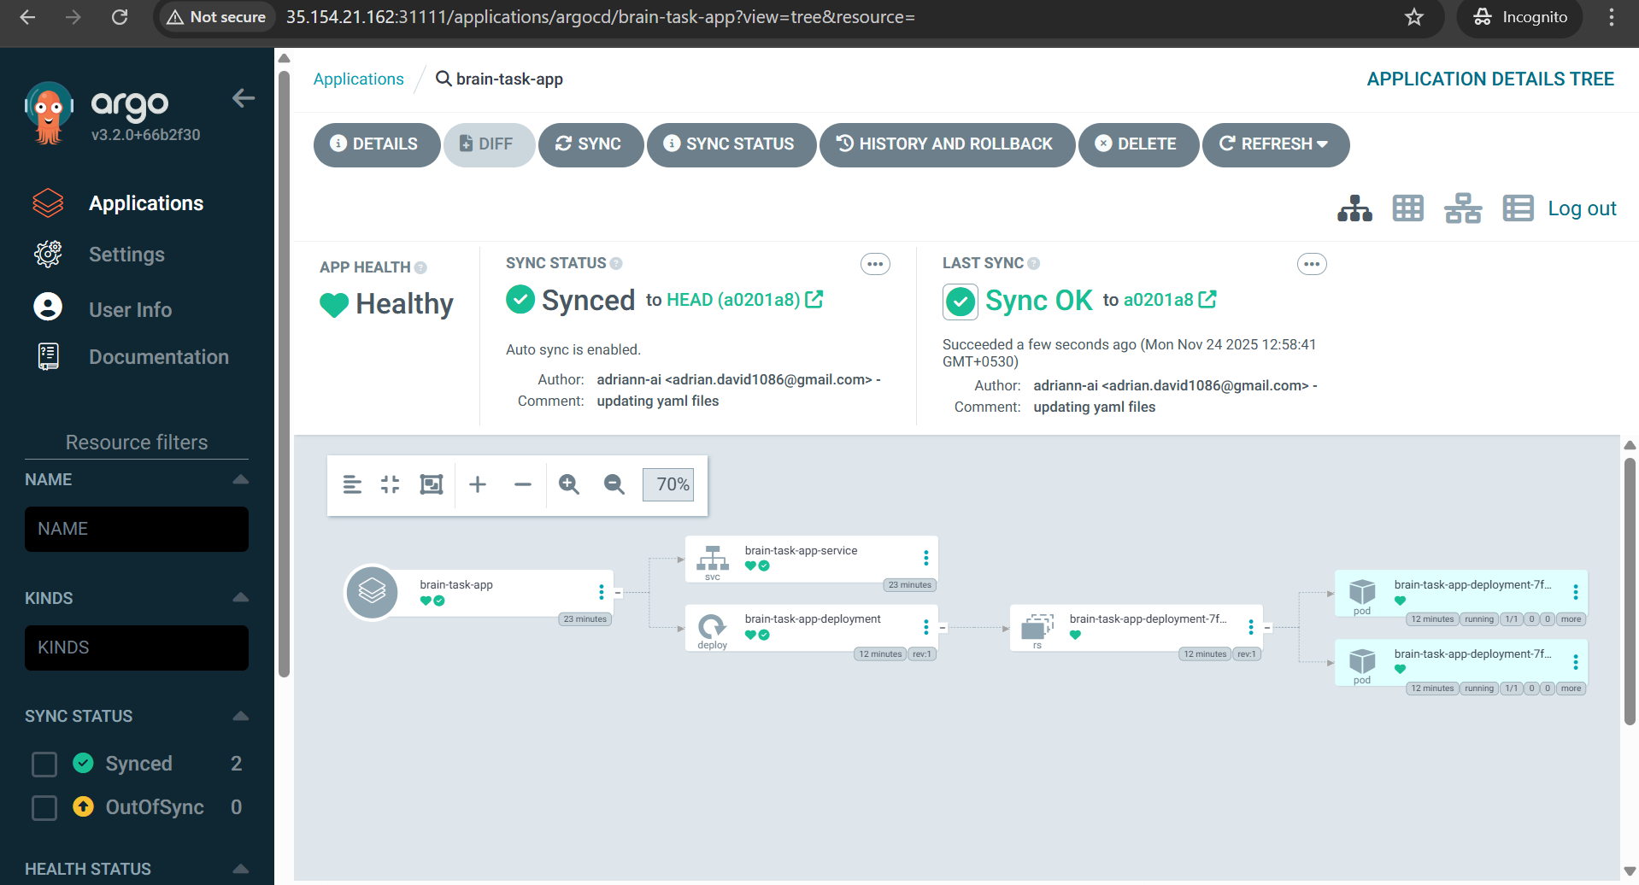

Monitoring the application deployment through Cloudwatch

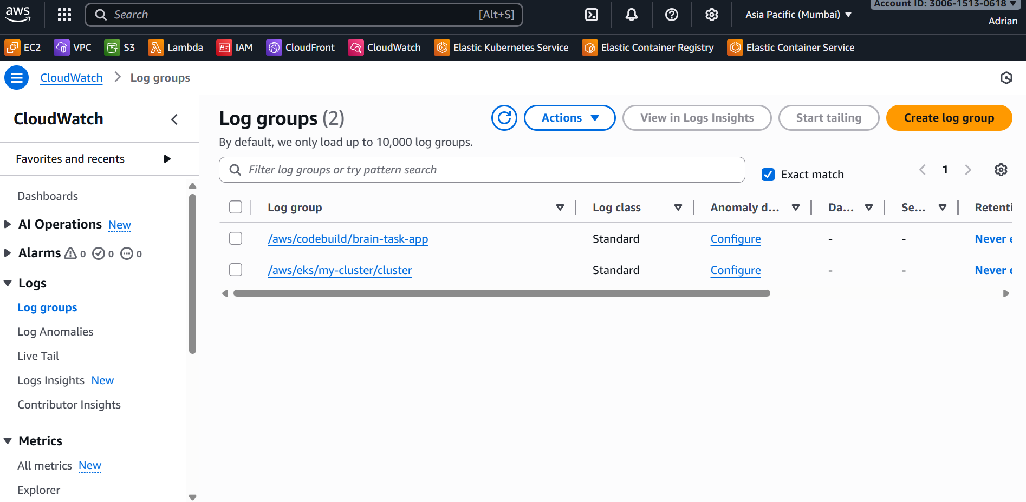

Cloudwatch giving crisp and clear logs

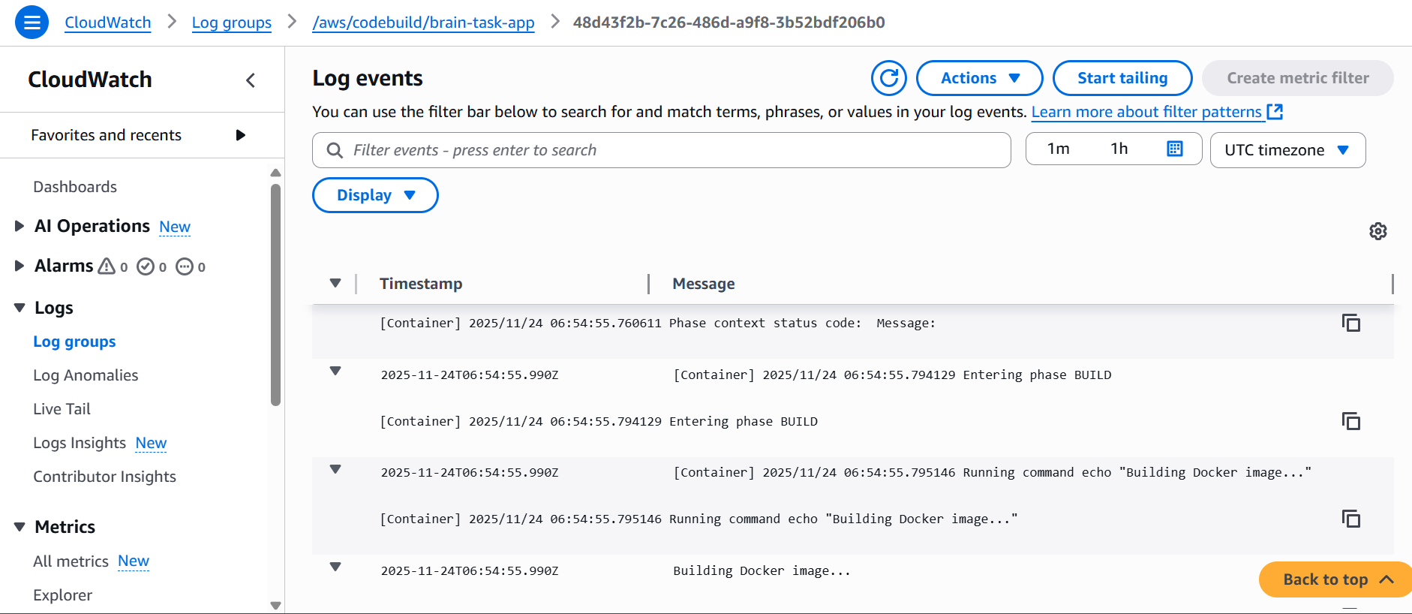

Complete logs FYR

timestamp,message

1763967275892,"[Container] 2025/11/24 06:54:30.227538 Running on CodeBuild On-demand

"

1763967275892,"[Container] 2025/11/24 06:54:30.227549 Waiting for agent ping

"

1763967275892,"[Container] 2025/11/24 06:54:30.529298 Waiting for DOWNLOAD_SOURCE

"

1763967275892,"[Container] 2025/11/24 06:54:31.790294 Phase is DOWNLOAD_SOURCE

"

1763967275892,"[Container] 2025/11/24 06:54:31.791315 CODEBUILD_SRC_DIR=/codebuild/output/src2876797086/src

"

1763967275892,"[Container] 2025/11/24 06:54:31.791809 YAML location is /codebuild/output/src2876797086/src/buildspec.yaml

"

1763967275892,"[Container] 2025/11/24 06:54:31.793677 Setting HTTP client timeout to higher timeout for S3 source

"

1763967275892,"[Container] 2025/11/24 06:54:31.793932 Processing environment variables

"

1763967275892,"[Container] 2025/11/24 06:54:32.013619 No runtime version selected in buildspec.

"

1763967275892,"[Container] 2025/11/24 06:54:32.031635 Moving to directory /codebuild/output/src2876797086/src

"

1763967275892,"[Container] 2025/11/24 06:54:32.031738 Cache is not defined in the buildspec

"

1763967275892,"[Container] 2025/11/24 06:54:32.128059 Skip cache due to: no paths specified to be cached

"

1763967275892,"[Container] 2025/11/24 06:54:32.128448 Registering with agent

"

1763967275892,"[Container] 2025/11/24 06:54:32.214542 Phases found in YAML: 4

"

1763967275892,"[Container] 2025/11/24 06:54:32.214566 POST_BUILD: 2 commands

"

1763967275892,"[Container] 2025/11/24 06:54:32.214571 INSTALL: 2 commands

"

1763967275892,"[Container] 2025/11/24 06:54:32.214575 PRE_BUILD: 2 commands

"

1763967275892,"[Container] 2025/11/24 06:54:32.214649 BUILD: 3 commands

"

1763967275892,"[Container] 2025/11/24 06:54:32.215065 Phase complete: DOWNLOAD_SOURCE State: SUCCEEDED

"

1763967275892,"[Container] 2025/11/24 06:54:32.215146 Phase context status code: Message:

"

1763967275892,"[Container] 2025/11/24 06:54:32.401429 Entering phase INSTALL

"

1763967275892,"[Container] 2025/11/24 06:54:32.479545 Running command apt update -y

"

1763967275892,"

"

1763967275892,"WARNING: apt does not have a stable CLI interface. Use with caution in scripts.

"

1763967275892,"

"

1763967275892,"Hit:1 https://apt.corretto.aws stable InRelease

"

1763967275892,"Get:2 https://cli.github.com/packages stable InRelease [3917 B]

"

1763967275892,"Get:3 https://dl.google.com/linux/chrome/deb stable InRelease [1825 B]

"

1763967275892,"Get:4 http://security.ubuntu.com/ubuntu jammy-security InRelease [129 kB]

"

1763967275892,"Hit:5 http://archive.ubuntu.com/ubuntu jammy InRelease

"

1763967275892,"Get:6 http://archive.ubuntu.com/ubuntu jammy-updates InRelease [128 kB]

"

1763967275892,"Get:7 https://cli.github.com/packages stable/main amd64 Packages [343 B]

"

1763967275892,"Get:8 https://ppa.launchpadcontent.net/mozillateam/ppa/ubuntu jammy InRelease [24.6 kB]

"

1763967275892,"Get:9 https://dl.google.com/linux/chrome/deb stable/main amd64 Packages [1209 B]

"

1763967275892,"Get:10 http://archive.ubuntu.com/ubuntu jammy-backports InRelease [127 kB]

"

1763967275892,"Get:11 http://security.ubuntu.com/ubuntu jammy-security/universe i386 Packages [848 kB]

"

1763967275892,"Get:12 https://ppa.launchpadcontent.net/mozillateam/ppa/ubuntu jammy/main i386 Packages [3989 B]

"

1763967275892,"Get:13 http://archive.ubuntu.com/ubuntu jammy-updates/restricted amd64 Packages [6222 kB]

"

1763967277928,"Get:14 https://ppa.launchpadcontent.net/mozillateam/ppa/ubuntu jammy/main amd64 Packages [45.0 kB]

"

1763967277928,"Get:15 http://security.ubuntu.com/ubuntu jammy-security/restricted amd64 Packages [5988 kB]

"

1763967277928,"Get:16 http://archive.ubuntu.com/ubuntu jammy-updates/universe i386 Packages [987 kB]

"

1763967277928,"Get:17 http://archive.ubuntu.com/ubuntu jammy-updates/universe amd64 Packages [1595 kB]

"

1763967277928,"Get:18 http://security.ubuntu.com/ubuntu jammy-security/universe amd64 Packages [1290 kB]

"

1763967277928,"Get:19 http://archive.ubuntu.com/ubuntu jammy-updates/main i386 Packages [1138 kB]

"

1763967277928,"Get:20 http://security.ubuntu.com/ubuntu jammy-security/main i386 Packages [904 kB]

"

1763967277928,"Get:21 http://archive.ubuntu.com/ubuntu jammy-updates/main amd64 Packages [3876 kB]

"

1763967277928,"Get:22 http://security.ubuntu.com/ubuntu jammy-security/main amd64 Packages [3532 kB]

"

1763967279941,"Fetched 26.8 MB in 3s (8762 kB/s)

"

1763967283957,"Reading package lists...

"

1763967283957,"Building dependency tree...

"

1763967283957,"Reading state information...

"

1763967283957,"6 packages can be upgraded. Run 'apt list --upgradable' to see them.

"

1763967283957,"

"

1763967283957,"[Container] 2025/11/24 06:54:43.369455 Running command apt install -y docker.io

"

1763967283957,"

"

1763967283957,"WARNING: apt does not have a stable CLI interface. Use with caution in scripts.

"

1763967283957,"

"

1763967285972,"Reading package lists...

"

1763967285972,"Building dependency tree...

"

1763967285972,"Reading state information...

"

1763967285972,"docker.io is already the newest version (28.2.2-0ubuntu1~22.04.1).

"

1763967285972,"docker.io set to manually installed.

"

1763967285972,"0 upgraded, 0 newly installed, 0 to remove and 6 not upgraded.

"

1763967285972,"

"

1763967285972,"[Container] 2025/11/24 06:54:45.279291 Phase complete: INSTALL State: SUCCEEDED

"

1763967285972,"[Container] 2025/11/24 06:54:45.279318 Phase context status code: Message:

"

1763967285972,"[Container] 2025/11/24 06:54:45.312225 Entering phase PRE_BUILD

"

1763967285972,"[Container] 2025/11/24 06:54:45.313608 Running command echo ""Amazon ECR login""

"

1763967285972,"Amazon ECR login

"

1763967285972,"

"

1763967285972,"[Container] 2025/11/24 06:54:45.319610 Running command aws ecr get-login-password --region ap-south-1 | docker login --username AWS --password-stdin $IMAGE_REPO

"

1763967295990,"WARNING! Your password will be stored unencrypted in /root/.docker/config.json.

"

1763967295990,"Configure a credential helper to remove this warning. See

"

1763967295990,"https://docs.docker.com/engine/reference/commandline/login/#credential-stores

"

1763967295990,"

"

1763967295990,"Login Succeeded

"

1763967295990,"

"

1763967295990,"[Container] 2025/11/24 06:54:55.760592 Phase complete: PRE_BUILD State: SUCCEEDED

"

1763967295990,"[Container] 2025/11/24 06:54:55.760611 Phase context status code: Message:

"

1763967295990,"[Container] 2025/11/24 06:54:55.794129 Entering phase BUILD

"

1763967295990,"[Container] 2025/11/24 06:54:55.795146 Running command echo ""Building Docker image...""

"

1763967295990,"Building Docker image...

"

1763967295990,"

"

1763967295990,"[Container] 2025/11/24 06:54:55.800977 Running command docker build -t brain-task-app .

"

1763967298023,"#0 building with ""default"" instance using docker driver

"

1763967298023,"

"

1763967298023,"#1 [internal] load build definition from Dockerfile

"

1763967298023,"#1 transferring dockerfile: 102B done

"

1763967298023,"#1 DONE 0.0s

"

1763967298023,"

"

1763967298023,"#2 [internal] load metadata for docker.io/library/httpd:latest

"

1763967300042,"#2 DONE 2.4s

"

1763967300042,"

"

1763967300042,"#3 [internal] load .dockerignore

"

1763967300042,"#3 transferring context: 2B done

"

1763967300042,"#3 DONE 0.0s

"

1763967300042,"

"

1763967300042,"#4 [internal] load build context

"

1763967300042,"#4 transferring context: 317.98kB done

"

1763967300042,"#4 DONE 0.0s

"

1763967300042,"

"

1763967300042,"#5 [1/2] FROM docker.io/library/httpd:latest@sha256:f9b88f3f093d925525ec272bbe28e72967ffe1a40da813fe84df9fcb2fad3f30

"

1763967300042,"#5 resolve docker.io/library/httpd:latest@sha256:f9b88f3f093d925525ec272bbe28e72967ffe1a40da813fe84df9fcb2fad3f30 0.0s done

"

1763967300042,"#5 sha256:1962df175a86aff6eefa4208caff11e4af980523213fdbcb81a93c19c629f5e7 2.09kB / 2.09kB done

"

1763967300042,"#5 sha256:0e4bc2bd6656e6e004e3c749af70e5650bac2258243eb0949dea51cb8b7863db 0B / 29.78MB 0.1s

"

1763967300042,"#5 sha256:f9b88f3f093d925525ec272bbe28e72967ffe1a40da813fe84df9fcb2fad3f30 10.14kB / 10.14kB done

"

1763967300042,"#5 sha256:c00bfb4edfeb0206fa0e988e51b588a442deca46cb4ea69b3cd7e08f93b429ae 7.99kB / 7.99kB done

"

1763967300042,"#5 sha256:4742a9e996d171d036e208e8261ee1a7278c9513f806a96dabcd6cfe66302739 0B / 145B 0.1s

"

1763967300042,"#5 sha256:4f4fb700ef54461cfa02571ae0db9a0dc1e0cdb5577484a6d75e68dc38e8acc1 0B / 32B 0.1s

"

1763967300042,"#5 sha256:4f4fb700ef54461cfa02571ae0db9a0dc1e0cdb5577484a6d75e68dc38e8acc1 32B / 32B 0.5s done

"

1763967300042,"#5 sha256:87a14f0839679cdf72421f2a7c5631a7e8a113354285298ce7e318c9ed8134fc 0B / 2.00MB 0.7s

"

1763967300042,"#5 sha256:0e4bc2bd6656e6e004e3c749af70e5650bac2258243eb0949dea51cb8b7863db 2.10MB / 29.78MB 0.8s

"

1763967300042,"#5 sha256:0e4bc2bd6656e6e004e3c749af70e5650bac2258243eb0949dea51cb8b7863db 11.53MB / 29.78MB 1.0s

"

1763967300042,"#5 sha256:4742a9e996d171d036e208e8261ee1a7278c9513f806a96dabcd6cfe66302739 145B / 145B 0.9s done

"

1763967300042,"#5 sha256:9cd0271fa7514efc0ced1e0bcdef82af8591b9006e3468633965deb4fd2085f9 0B / 13.43MB 1.0s

"

1763967300042,"#5 sha256:0e4bc2bd6656e6e004e3c749af70e5650bac2258243eb0949dea51cb8b7863db 20.97MB / 29.78MB 1.2s

"

1763967300042,"#5 sha256:87a14f0839679cdf72421f2a7c5631a7e8a113354285298ce7e318c9ed8134fc 2.00MB / 2.00MB 1.1s done

"

1763967300042,"#5 sha256:5b4d5959fc7583ac425d94096a05b143ec3547d698d6d202e07f37ee1366db72 0B / 291B 1.2s

"

1763967302056,"#5 sha256:0e4bc2bd6656e6e004e3c749af70e5650bac2258243eb0949dea51cb8b7863db 27.26MB / 29.78MB 1.3s

"

1763967302056,"#5 sha256:0e4bc2bd6656e6e004e3c749af70e5650bac2258243eb0949dea51cb8b7863db 29.78MB / 29.78MB 1.4s done

"

1763967302056,"#5 extracting sha256:0e4bc2bd6656e6e004e3c749af70e5650bac2258243eb0949dea51cb8b7863db

"

1763967302056,"#5 sha256:9cd0271fa7514efc0ced1e0bcdef82af8591b9006e3468633965deb4fd2085f9 2.10MB / 13.43MB 1.5s

"

1763967302056,"#5 sha256:9cd0271fa7514efc0ced1e0bcdef82af8591b9006e3468633965deb4fd2085f9 7.34MB / 13.43MB 1.6s

"

1763967302056,"#5 sha256:9cd0271fa7514efc0ced1e0bcdef82af8591b9006e3468633965deb4fd2085f9 13.43MB / 13.43MB 1.7s

"

1763967302056,"#5 sha256:5b4d5959fc7583ac425d94096a05b143ec3547d698d6d202e07f37ee1366db72 291B / 291B 1.6s done

"

1763967302056,"#5 sha256:9cd0271fa7514efc0ced1e0bcdef82af8591b9006e3468633965deb4fd2085f9 13.43MB / 13.43MB 1.7s done

"

1763967302056,"#5 extracting sha256:0e4bc2bd6656e6e004e3c749af70e5650bac2258243eb0949dea51cb8b7863db 1.1s done

"

1763967302056,"#5 extracting sha256:4742a9e996d171d036e208e8261ee1a7278c9513f806a96dabcd6cfe66302739

"

1763967302056,"#5 extracting sha256:4742a9e996d171d036e208e8261ee1a7278c9513f806a96dabcd6cfe66302739 done

"

1763967302056,"#5 extracting sha256:4f4fb700ef54461cfa02571ae0db9a0dc1e0cdb5577484a6d75e68dc38e8acc1 done

"

1763967302056,"#5 extracting sha256:87a14f0839679cdf72421f2a7c5631a7e8a113354285298ce7e318c9ed8134fc 0.1s

"

1763967302056,"#5 extracting sha256:87a14f0839679cdf72421f2a7c5631a7e8a113354285298ce7e318c9ed8134fc 0.1s done

"

1763967302056,"#5 extracting sha256:9cd0271fa7514efc0ced1e0bcdef82af8591b9006e3468633965deb4fd2085f9 0.1s

"

1763967304070,"#5 extracting sha256:9cd0271fa7514efc0ced1e0bcdef82af8591b9006e3468633965deb4fd2085f9 0.4s done

"

1763967304070,"#5 extracting sha256:5b4d5959fc7583ac425d94096a05b143ec3547d698d6d202e07f37ee1366db72

"

1763967304070,"#5 extracting sha256:5b4d5959fc7583ac425d94096a05b143ec3547d698d6d202e07f37ee1366db72 done

"

1763967304070,"#5 DONE 3.6s

"

1763967304070,"

"

1763967304070,"#6 [2/2] COPY dist/ /usr/local/apache2/htdocs/

"

1763967304070,"#6 DONE 0.7s

"

1763967304070,"

"

1763967304070,"#7 exporting to image

"

1763967304070,"#7 exporting layers 0.0s done

"

1763967304070,"#7 writing image sha256:e5c06a5a49b891b64bd723fbe1a76ffe590b69240e99f3875fba8639ff9d229f done

"

1763967304070,"#7 naming to docker.io/library/brain-task-app done

"

1763967304070,"#7 DONE 0.0s

"

1763967304070,"

"

1763967304070,"[Container] 2025/11/24 06:55:03.197884 Running command docker tag brain-task-app:latest $IMAGE_REPO:$IMAGE_TAG

"

1763967304070,"

"

1763967304070,"[Container] 2025/11/24 06:55:03.221541 Phase complete: BUILD State: SUCCEEDED

"

1763967304070,"[Container] 2025/11/24 06:55:03.221556 Phase context status code: Message:

"

1763967304070,"[Container] 2025/11/24 06:55:03.254318 Entering phase POST_BUILD

"

1763967304070,"[Container] 2025/11/24 06:55:03.255570 Running command echo ""Pushing Docker image to ECR...""

"

1763967304070,"Pushing Docker image to ECR...

"

1763967304070,"

"

1763967304070,"[Container] 2025/11/24 06:55:03.261440 Running command docker push $IMAGE_REPO:$IMAGE_TAG

"

1763967304070,"The push refers to repository [300615130618.dkr.ecr.ap-south-1.amazonaws.com/brain-task-app]

"

1763967304070,"3ddf46742447: Preparing

"

1763967304070,"3ecb2dcd5414: Preparing

"

1763967304070,"1b73832a4868: Preparing

"

1763967304070,"5dc0365682c6: Preparing

"

1763967304070,"5f70bf18a086: Preparing

"

1763967304070,"de88e4999fda: Preparing

"

1763967304070,"70a290c5e58b: Preparing

"

1763967304070,"de88e4999fda: Waiting

"

1763967304070,"70a290c5e58b: Waiting

"

1763967304070,"3ecb2dcd5414: Pushed

"

1763967304070,"5f70bf18a086: Pushed

"

1763967304070,"3ddf46742447: Pushed

"

1763967306083,"5dc0365682c6: Pushed

"

1763967306083,"de88e4999fda: Pushed

"

1763967306083,"1b73832a4868: Pushed

"

1763967308099,"70a290c5e58b: Pushed

"

1763967308752,"latest: digest: sha256:e824e793af0627628207eca0fbdf4d6638c5153fbec36330cc95e77a1c2c4e88 size: 1782

"

1763967308752,"

"

1763967308752,"[Container] 2025/11/24 06:55:08.495912 Phase complete: POST_BUILD State: SUCCEEDED

"

1763967308752,"[Container] 2025/11/24 06:55:08.495939 Phase context status code: Message:

"

1763967308752,"[Container] 2025/11/24 06:55:08.538480 Set report auto-discover timeout to 5 seconds

"

1763967308752,"[Container] 2025/11/24 06:55:08.538519 Expanding base directory path: .

"

1763967308752,"[Container] 2025/11/24 06:55:08.540059 Assembling file list

"

1763967308752,"[Container] 2025/11/24 06:55:08.540071 Expanding .

"

1763967308752,"[Container] 2025/11/24 06:55:08.541722 Expanding file paths for base directory .

"

1763967308752,"[Container] 2025/11/24 06:55:08.541732 Assembling file list

"

1763967308752,"[Container] 2025/11/24 06:55:08.541736 Expanding **/*

"

1763967308752,"[Container] 2025/11/24 06:55:08.543517 No matching auto-discover report paths found

"

1763967308752,"[Container] 2025/11/24 06:55:08.543531 Report auto-discover file discovery took 0.005051 seconds

"

1763967308752,"[Container] 2025/11/24 06:55:08.543589 Phase complete: UPLOAD_ARTIFACTS State: SUCCEEDED

"

1763967308752,"[Container] 2025/11/24 06:55:08.543596 Phase context status code: Message:

"